Data Code & RStudio

Unit 1 - Lab 1

Directions: Follow along with the slides and answer the questions in **red** font in your journal.

# Data Science & R

* The R programming language is one of the main tools used by actual data scientists.
* RStudio packages the R language into an easy to use interface.

# So let's get started!

* Step one in any data science project is to load some data!
* Type these two commands into the your console:

load("~/Dropbox/IDS Curriculum Design/Labs/Unit 1 Labs/Data/cdc.rda")

View(cdc)

**What happened in RStudio after you ran these two commands?**

# Centers for Disease Control (CDC) Data

* The CDC is a federal insitution that studies public health.
  + **Why should we bother studying public health?**
  + **How might we study it?**
* Our data comes from a survey of high school aged Americans.
  + **How do you think the data were collected?**

# Look again at our data

* Type View(cdc) into your console again and answer the following questions:
  + **What does each horizonal row of the data represent?**
  + **What information is the first vertical column telling us?**
  + **How are the rows of the data different from the columns?**

# Data, Variables & Observations

* Data can be broken up into two parts.
  1. Observations
  2. Variables
* Answer the following questions about the CDC data
  + **Where are the observations and where are the variables in View(cdc)?**
  + **What are the differences between observations and variables?**
  + **How are variables and observations related?**

# Uncovering our Data's Structure

* RStudio's main window is composed of four *panes*
* Find the pane that has a *tab* titled *Environment* and click on it.
  + **Can you find the number of people surveyed?**
  + **How many variables are there for each person?**
  + **What happens when you click on cdc?**

# Uncovering our Data's Structure

* From the *Environment* tab, click on the blue arrow to the left of cdc
* Don't be overwhelmed! This is just some of the *structure* of our data:
  + We'll learn much more about this *structure* in the future.
  + Do you notice the names of the variables are listed?

# Type the following commands into the console

dim(cdc)

nrow(cdc)

ncol(cdc)

names(cdc)

* **Write each *output* and what it tells us about the people in our CDC data**
  + The *output* is what gets printed after you hit *enter*

# Baby Steps to Programming

* Typing commands into the console is your first step into the larger world of *programming* or *coding* (terms which are often used interchangeably).
  + *Programming* helps data scientist pull really useful information from the data.
* Coding is about learning how to send instructions to your computer.
  + We call the way we *speak* to the coding language, **syntax**.

# R's most important syntax

**

*function* (y~x, data = ____ )

**

* Look through the different panes for the *Plots* tab and click it.
* Then type the following commands into the console:

histogram(~height, data = cdc)

bargraph(~sunscreen, data = cdc)

xyplot(weight~height, data = cdc)

# Your First Plots

* **How are these two plots similar?**
* **How are these two plots different?**

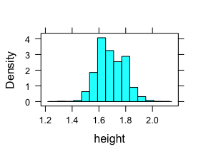

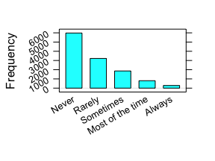

# Let's discuss

* In your teams:
  + Discuss the answers to the **red** questions you wrote down in your journals.
  + Agree on a single answer for each question.